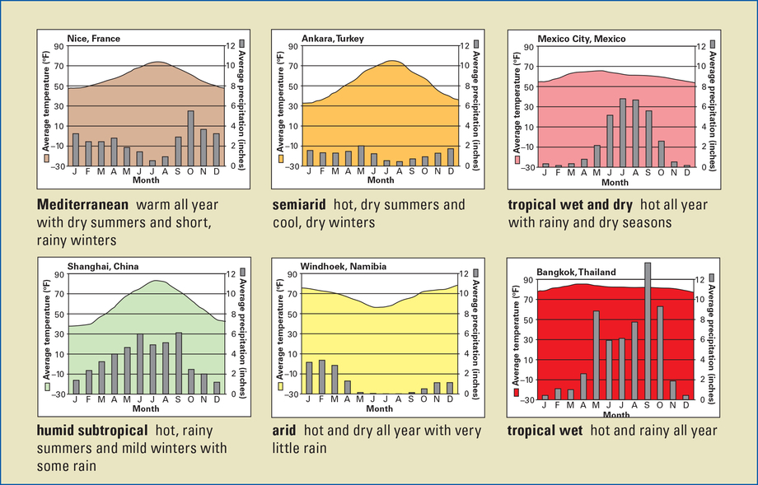

<b>World Climate Zones</b><br>
Examine these climagraphs for 12
different climate zones found around
the world.