Mapping Lab: Latin America

MAKING A MENTAL MAP

1. Draw an outline map of Latin America. Then draw and label these features where you think they are located:
• the equator
• other regions or bodies of water that you think lie north, south, east, and west of this region
• the area(s) that you think have a humid, tropical climate
• the area(s) that you think have a cold, polar climate
• the area(s) that you think have the greatest population
• the area(s) that you think have the least population

Latin America

Introduction
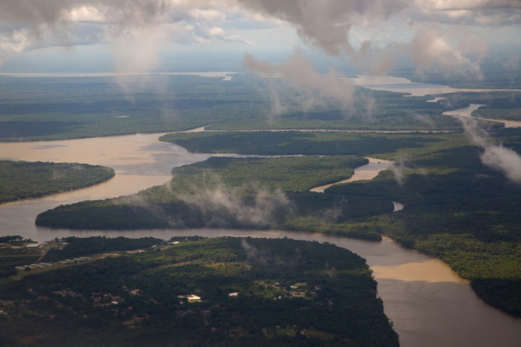
Latin America includes all the countries in the Western Hemisphere, except the United States and Canada. It has three sub-regions: Mexico and Central America, the Caribbean islands, and South America.
To the north lies Mexico, which shares a border with the United States. Mexico is connected to South America by a 1,200-milelong land bridge. This land bridge is known as Central America. East of Central America lie the many islands of the Caribbean Sea. South America is a long continent. Its hot northern lands span the equator, and its cool southern tip reaches toward the Antarctic Circle.
Watch the video shown by your teacher. This video shows a physical feature of this region.
What do you want to know about physical geography of Latin America?

Physical Features
Smoking volcanoes, dripping rainforests, and bone-dry deserts—Latin America has them all. Almost every physical feature on Earth is found in this vast region. But one feature runs from the north of Mexico to the tip of South America: mountains. For centuries, these mountains have kept the peoples of Latin America isolated from one another.

Mexico and Central America
On a map, Mexico and Central America look like a kite with a long tail.Baja California dangles off the top of the kite. The Yucatán Peninsula juts out from the bottom into the Gulf of Mexico.
Two great mountain ranges run north and south through Mexico. The Sierra Madre Occidental lines the west coast. The Sierra Madre Oriental lines the east coast. A high plain called the Mexican Plateau lies between the two ranges.
Mountains also run through Central America. Many of these mountains are active volcanoes. From Panama’s highest peak, you can look down on two different oceans.
The Isthmus of Panama connects Central America to South America. An isthmus is a narrow strip of land that links two larger landmasses. The Panama Canal was built across this isthmus in the early 1900s. It allows ships to travel between the Atlantic and Pacific oceans without going around all of South America.

The Caribbean Islands
The Caribbean islands curve in an arc from the tip of Florida to the north coast of South America. There are at least 7,000 dots of land in this island group. A few of these islands support large populations. Others are too small to put on most maps.
Many of these islands are the tops of submerged mountains. Volcanic islands rise steeply from warm beaches to rugged peaks. Tiny sea creatures known as coral formed other islands. Coral islands are flat and sandy.

South America
South America is shaped like a giant triangle. The Andes Mountains line the western side of the triangle. Plains and plateaus cover the rest. The vast Amazon basin covers much of the center of the continent. Further south lie grassy plains called the Pampas.
South America has many amazing physical features. They include these:
- the Amazon River—the world’s second longest river. The Amazon carries more water than any other river in the world.
- Lake Titicaca—the highest lake in the world that can be used for boat travel. This large lake has more than 40 islands.
- the Atacama Desert—one of the driest places on Earth. Average rainfall in the Atacama is only half an inch a year.
- Angel Falls—the world’s highest waterfall. The water drops down a rocky cliff for nearly two-thirds of a mile.

After you read the section on physical features. Get a Physical Features map from your teacher. Find two or more sentences in the reading with information represented in the map and write them below. Be prepared to share what you found with the class.

Climate
Latin America is a region of many climates. One reason is that it spans a huge range of latitudes. As you read in Lesson 2, climate generally varies with latitude. Low latitudes, close to the equator, have a year-round tropical climate. High latitudes, near the poles, have short summers and long, cold winters. Between those two extremes lie the middle latitudes, which have more temperate, or mild, climates.
Another reason Latin America has such diverse climates is its wide range of altitudes. Altitude has much the same effect on climate as latitude. The higher the altitude, the colder the climate. At lower elevations, mountain climates may be tropical. At higher elevations, the climate can be very cold.

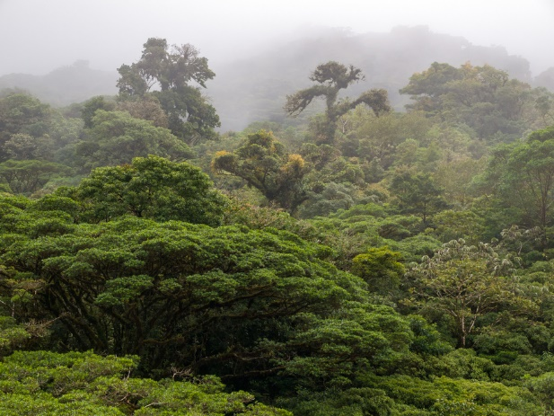
Mexico and Central America
Mexico’s climate ranges from arid in the north to tropical in the south. The Mexican Plateau is more temperate, with a semiarid climate. Closer to the coast, the climate becomes tropical wet and dry. Mexicans call this tropical area the “Tierra Caliente,” or hot land.
The climate of Central America is tropical near the coast. The air becomes cooler in the mountains. The mountains of Costa Rica are home to a rare ecosystem known as a cloud forest. Low clouds hang over this forest all year round. Mist from the clouds collects on leaves and drips off the trees like rain. The result is a high-elevation rainforest.
A unique ecosystem known as a cloud forest is found in the mountains of Central America.

The Caribbean Islands
Most of the Caribbean islands also have a tropical wet and dry climate.People from North America and Europe enjoy winter vacations on these tropical islands.
Huge storms called hurricanes are common during summer months.These huge swirling storms form over warm seas near the equator. Then, they move toward the poles in a wide, destructive path. Hurricane winds can reach more than 150 miles per hour. At that speed, they can easily knock over trees and tear the roofs off houses.

South America
In South America, climate varies with both latitude and altitude. The northern half of the continent nearest the equator is mostly tropical wet.Further south, the climate becomes subtropical and even arid. The Andes Mountains have a highlands climate. This means that the climate varies by elevation, getting colder the higher one goes.

Geoterms:
temperate: moderate or mild, without extremes of hot or cold
semiarid: dry, with little rainfall; also a climate or climate zone with hot, dry summers and cool, dry winters
tropical wet and dry: a climate or climate zone that is hot all year with rainy and dry seasons
ecosystem: community of all the living things in an area and the environment in which they live
cloud forest: a type of high-altitude, tropical forest that is usually covered by clouds or mist
hurricanes: the name for a tropical cyclone that begins in the Atlantic Ocean
highlands: a mountainous part of a country; a climate zone where temperature and precipitation vary with latitude and elevation; a vegetation zone where the mix of plants varies with latitude and elevation; also refers to the type of vegetation in this zone
After you read the section on Climate. Get a Climate Zones map from your teacher. Find two or more sentences in the reading with information represented in the map and write them below. Be prepared to share what you found with the class.

Vegetation

With so many climates, it is no surprise that Latin America is home to an incredible variety of plants. The most widespread type of vegetation is broadleaf evergreen forest. It occurs in both tropical wet and tropical wet and dry climate zones.
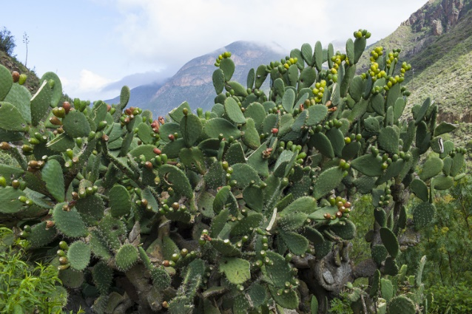
In a broadleaf evergreen forest, most or all of the trees have leaves rather than needles. But unlike broadleaf trees in cooler climates, these trees do not lose their leaves in winter. Instead, they are green all year round. Rainforests and jungles are examples of broadleaf evergreen forests. So are the cloud forests of Central America.

Mexico and Central America
In Mexico, what plants grow where depends mainly on rainfall. Desert scrub covers the arid north. Cactus plants survive here with little water. Forest once covered the Mexican Plateau. Over time, most of the trees were cleared to make way for farms.
Huge cactus plants grow with little rain in the deserts of Mexico.

Southern Mexico and Central America are covered with broadleaf evergreen forest. Pine and oak trees are found in the high cloud forests. Along the coasts, palms, figs, vines, and Spanish moss create a dense rainforest.

The Caribbean Islands
The Caribbean islands have a mix of tropical grasslands and broadleaf evergreen forests. Black and red mangrove trees and coconut palms are typical trees. Underwater coral reefs circle many of the islands.These reefs are home to broad-leafed turtle grass, feathery green algae, and red algae that can make the coral look rusty.

South America
The largest vegetation zone in South America is the Amazon rainforest. This broadleaf evergreen forest is home to more kinds of plants than any other place on Earth. There are hardwood trees, such as mahogany and rosewood, which people use to make furniture. There are also Brazil nut and rubber trees. The forest floor is a tangle of plants, vines, and colorful orchids.
Tropical grasslands and temperate grasslands cover most of the rest of South America. Cacti and flowering plants bloom in desert scrub regions. The Atacama Desert is so dry that almost no plants survive there.

Geoterms
broadleaf evergreen forest: a vegetation zone of mainly tall trees that remain green all year; also refers to the type of vegetation in this zone
Desert scrub: a vegetation zone of mainly small trees, bushes, and other plants adapted to a dry climate; also refers to the type of vegetation in this zone
tropical grasslands: vegetation or a vegetation zone of mainly grasses and scattered trees adapted to a tropical wet and dry climate

After you read the section on vegetation zones. Get a Vegetation Zones map from your teacher. Find two or more sentences in the reading with information represented in the map and write them below. Be prepared to share what you found with the class.

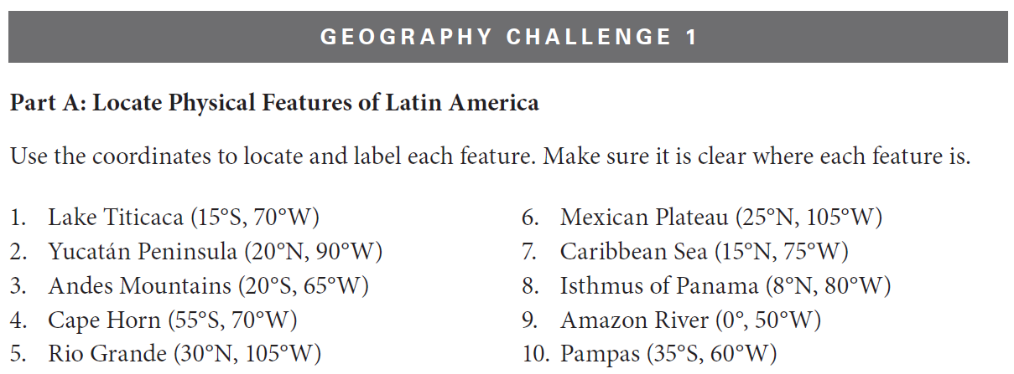

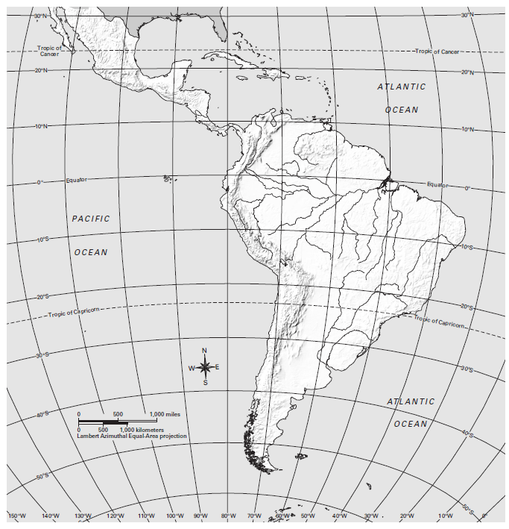

Human Geography

Latin America is home to 33 countries and more than 645 million people. Brazil is the largest country in both area and population. About 210 million people lived in Brazil in 2017. This means that almost one Latin American out of three was a Brazilian. Brazil is the largest country in the world where Portuguese is the first language.
This region is called Latin America because most of its people speak Spanish or Portuguese. Both are modern languages based on Latin. This was a language spoken in the Roman Empire about 2,000 years ago. Languages based on Latin are called Romance languages because of their Roman roots.

Watch the video shown by your teacher. This video shows an example of human activity in this region.
What do you want to know about human geography of Canada and the United States?

History
Over time, many peoples have come to Latin America. Each group has left its mark on the history of this region.

Early Times
The first Americans were probably hunter-gatherers from Asia. They may have followed animals they hunted across a land bridge that once connected Asia to Alaska. Their descendants spread to the tip of South America.
Over time, some native peoples learned how to farm. Their most important crops were maize (corn) and the potato. Farming allowed native peoples to settle down in one place. It also led to the growth of civilizations.
The Maya created civilizations in Mexico and Central America. Four hundred years later, the Aztecs built their empire in Mexico. The Incas built a large empire that spread down the western coast of South America.

The Colonial Period
In 1492, a European explorer named Christopher Columbus landed in the Caribbean. His discovery brought more Europeans to the Americas. They brought European animals, plants, and diseases. They took back plants, animals, and diseases that had not been seen in Europe before. This swapping of items is called the Columbian Exchange. It changed how people in Europe and the Americas lived.
In the early 1500s, Spain conquered the Aztec and Inca empires. This began a long period of European colonization. Many native peoples died fighting the colonists. But European diseases were even deadlier than war. As the native peoples died, Europeans brought Africans over to work as slaves.
Spain and Portugal took over most of Latin America. Spanish and Portuguese replaced many native languages. Many native peoples became Christians.
In time, Latin Americans began to rebel against the European rulers. Wars for independence began in 1791 with a slave uprising in Haiti. By 1825, most of Latin America had thrown off colonial rule. One of the first acts of the newly independent countries was to outlaw slavery. The exception was Brazil, which did not free its slaves until 1888.

The Modern Era
Independence did not bring democracy to Latin America as it had to the United States. From Mexico to Argentina, military leaders seized power and ruled as dictators. Most dictators were only interested in holding onto power. They cared little about the rights or welfare of their people.
By the 1980s, Latin Americans were weary of dictators. In one country after another, the people demanded the right to choose their leaders. Today, elected governments run most Latin American countries. Democracy has not solved all of Latin America’s problems. Poverty is widespread. Schools are poor. Governments are unstable. Living standards remain low. But for many Latin Americans, the right to vote has brought with it hope for a better future.
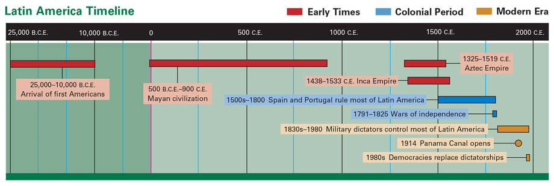
Geoterms
empire: a group of territories, peoples, or nations ruled by a single authority

After you read the section on history. Find two or more sentences in the reading with information represented on the timeline and write them below. Be prepared to share what you found with the class.

Population
Latin America includes about 15 percent of the world’s land area. But it is home to less than 9 percent of the world’s people. Still, its population is growing fast. From 1950 to 2010, the number of Latin Americans more than tripled.

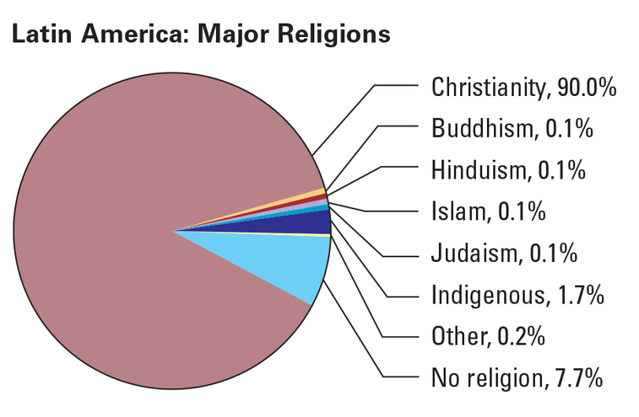
As the population grows, it is becoming more urban. In 1950, more than half of Latin Americans lived on farms. Today, three-fourths live in urban areas. Most large cities are located on the coasts.
Most Latin Americans are Christian. This region is home to nearly 40 percent of the world’s one billion Roman Catholics. However, other Christian churches are gaining members.
Some Latin Americans still follow indigenous religions. These are traditional beliefs held by native peoples. The “Other” category in the circle graph below includes several religious traditions. Some of these traditions were brought to the Americas long ago by Africans. Others were brought by more recent immigrants from Asia.

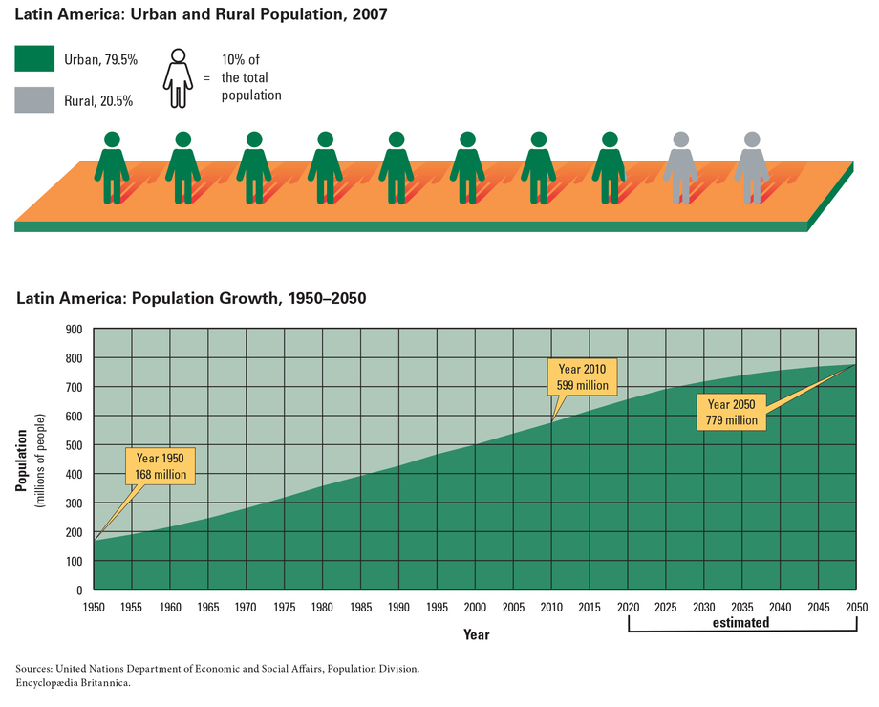
Geoterms
urban: found or living in a city

After you read the section on population. Find two or more sentences in the reading with information represented on the Population Density map and write them below. Be prepared to share what you found with the class.

Economic Activity
Latin America has a wealth of natural resources. Those resources support a broad range of economic activities. Some of the most widespread economic activities are livestock raising and subsistence farming.
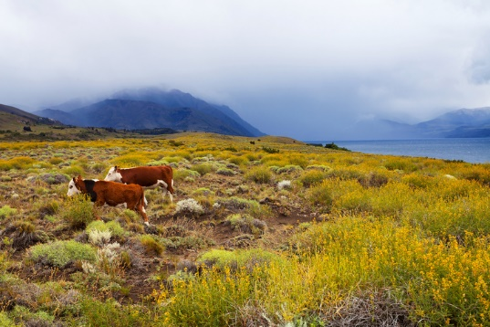
Cattle ranching is a major industry in the Pampas region of Argentina. This large plains region cover about 295,000 square miles.

Subsistence farmers usually grow only enough food to feed their families. Good weather may sometimes allow them to produce a crop surplus. They can then sell orbarter their extra food for other things they need. But surpluses are rare. As a result, subsistence farmers are generally poor. The most important crops grown by subsistence farmers are corn, potatoes, and beans.

Resources
The Europeans who first came to Latin America wanted its mineral wealth. They were interested mainly in mining silver and gold. Later, people mined copper, uranium, and other minerals as well. Most of these metals are found in the Andes Mountains.
Today, Latin America is better known for its energy resources. Mexico and Venezuela export about 6 percent of the world’s oil. Many countries in Latin America are also moving toward natural gas production as well.
Latin American rivers are another source of energy. Dams on rivers in Brazil and Paraguay produce large amounts of hydroelectric power.
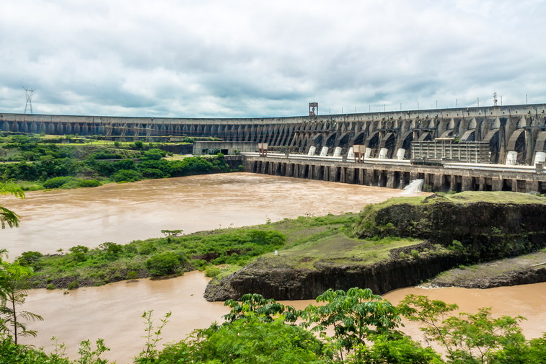
The Itaipu Hydroelectric Dam is located between Brazil and Paraguay. It produces more hydroelectric energy than any other dam in the world.

Land Use
Farming and ranching are important across Latin America. One of the most important commercial farming crops is coffee. Coffee beans are grown on large plantations in Brazil, Colombia, and Central America. Ranchers raise mostly cattle and sheep. The largest cattle ranches are found on the Pampas of Argentina.
Forestry is another major industry. Many types of trees are harvested from Latin American forests. This wood is used for building materials and fuel. It is also used to make products such as furniture and musical instruments.
Some areas in Latin America specialize in a particular activity. The most important industry in the Caribbean islands, for example, is tourism. Mexico, in contrast, is strong in manufacturing. Many of the cars you see on American roads were made in Mexico.

Geoterms
livestock raising: raising animals for food, milk, wool, or other products
subsistence farming: farming carried out mainly to provide food for farm families, with little surplus for sale to others
hydroelectric power: electricity that is generated from the power of moving water
tourism: travel for pleasure rather than business or necessity; also, the business of organizing such travel

After you read the section on economic activity. Find two or more sentences in the reading with information represented on the Economic Activity map and write them below. Be prepared to share what you found with the class.

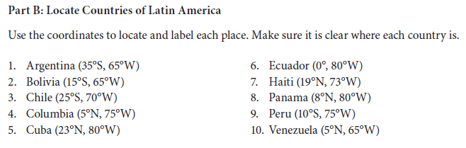
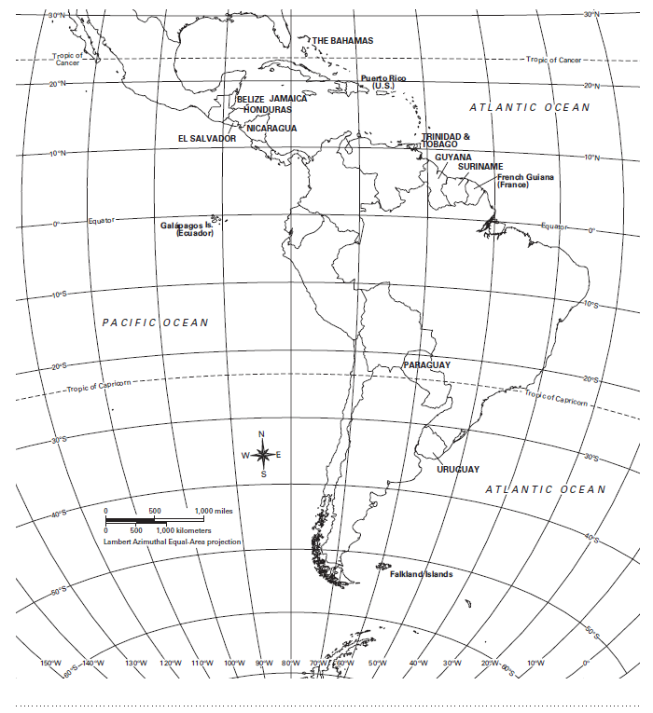

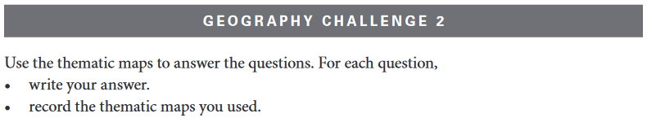
Question | Answer

1. Through which seven Latin American countries do the Andes Mountains run?

Map Used:

2. What is the most common type of vegetation throughout Latin America? Which country has the most land with that type of vegetation?

Map Used:

3. What is Latin America’s most populated city north of the equator? Which are the three most populated cities south of the equator?

Map Used:

4. Which resource is most abundant in Latin America north of the equator? Which two countries have the most of that resource?

Map Used:

5. What important physical feature is found near 10°N latitude and 80°W longitude? In which country is it located?

Map Used:

6. Which two countries and a neighboring territory have the lowest population density in Latin America?

Map Used:

7. Which two Latin American countries have the most desert vegetation? Which four countries have the most desert scrub vegetation?

Map Used:

8. Name four Latin American countries where most of the precious metals (gold, silver, copper) are found. What physical feature do these countries have in common that might explain why?

Map Used:

9. Which three Latin American countries have the most land for livestock raising? In which one of these countries do climate and vegetation make the land most suitable for livestock raising? Why?

Map Used:

10. How many people live in the urban center of Buenos Aires, Argentina? How do economic activity and climate help explain why so many people live in Buenos Aires?

Map Used:
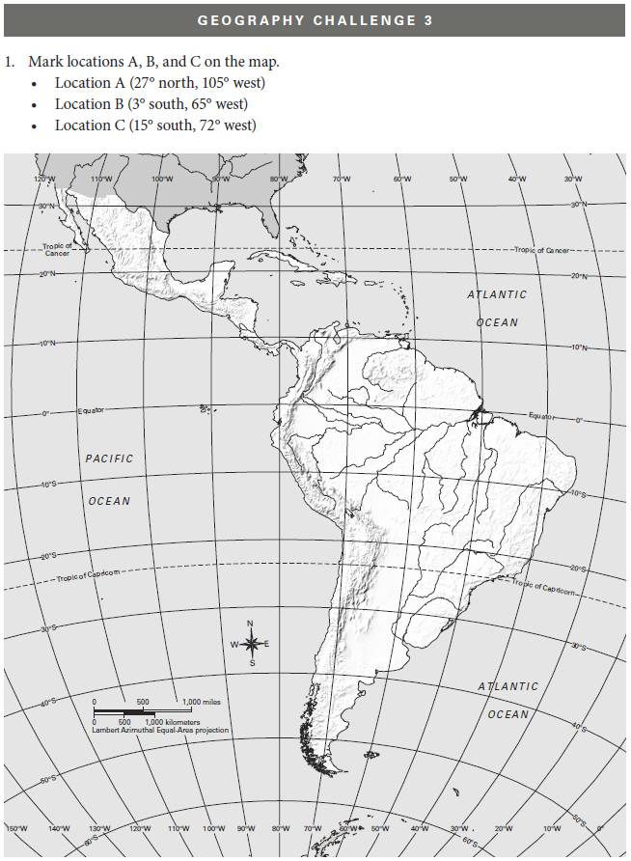
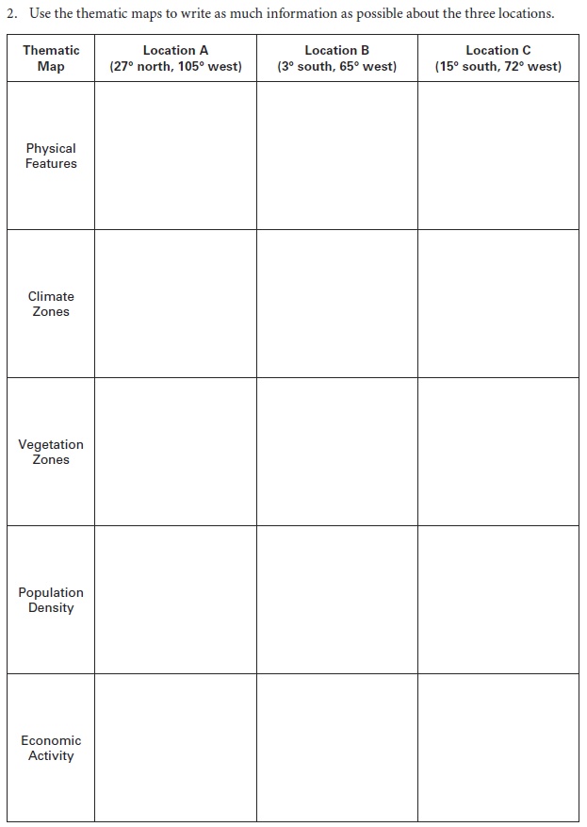
Where Are You! Game

We think the field photograph best matches Location _______ .

Supporting-evidence statements:

1. From the ___________________________________________________ map, we learned that this location …
In the field photograph, we see …

2. From the ___________________________________________________ map, we learned that this location …
In the field photograph, we see …

3. From the ___________________________________________________ map, we learned that this location …
In the field photograph, we see …

Spatial Inequality in Mexico City:
From Shacks to Skyscrapers

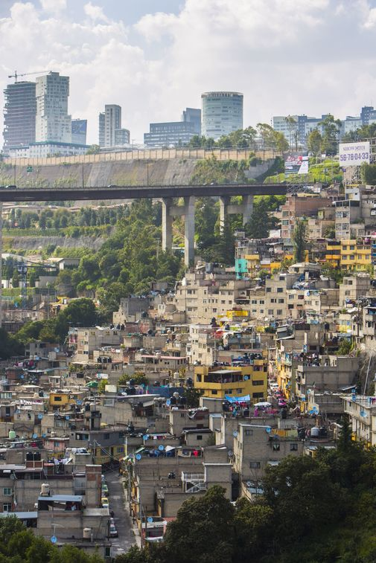
Introduction
Wealthier and poorer areas of Mexico City are physically separated from one another.
Anna Romero lives in a poor part of Mexico City. She and her family of six share a simple two-room house made of concrete blocks, corrugated metal, and scraps of wood. There is no glass in the windows, and there is no running water. The Romeros must walk to a water tap they share with their neighbors.
Six days a week, Anna travels by bus to her job as a maid for the Alba family. The Albas live on the other side of Mexico City in a beautiful 15-room house with a large garden and swimming pool. To Anna, the Alba home seems like a castle. The Albas pay Anna less than $15 for a 12-hour day of cleaning, cooking, and doing laundry. At 7:00 P.M., as the Albas sit down to a big meal of chicken, meat, or fish, Anna begins her journey home to cook rice and beans for her family.
Wealthier and poorer areas of Mexico City are physically separated from one another.
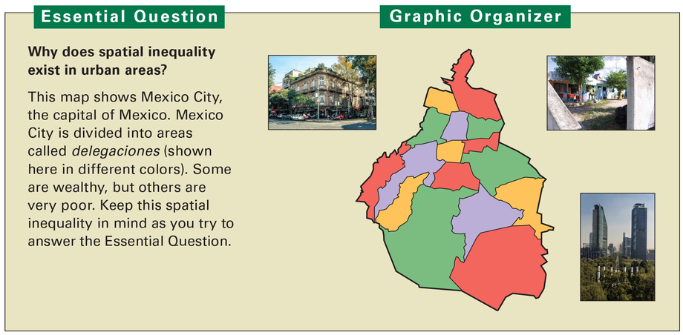
The Albas and Romeros live just 15 miles apart in the same city, but in some ways they live in different worlds. The contrast between their two ways of life is an example of spatial inequality, or an unequal distribution of wealth or resources over a geographic area. It means that some places within that area are richer or poorer than others. Mexico City offers many examples of spatial inequality.
In this lesson, you will learn about the growth of Mexico City as an urban area. You will read about the causes and effects of the city’s rapid growth. You will also learn about the spatial inequality that has resulted from the city’s expansion.

Geoterms:
spatial inequality: the unequal distribution of wealth or resources in a geographic area, so that some places are richer than others
urban: found or living in a city

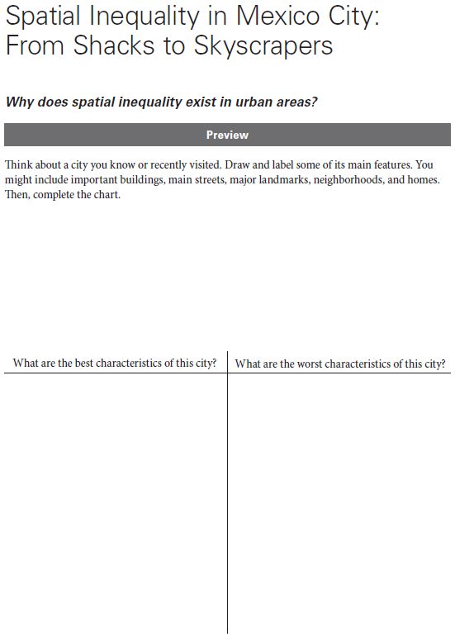

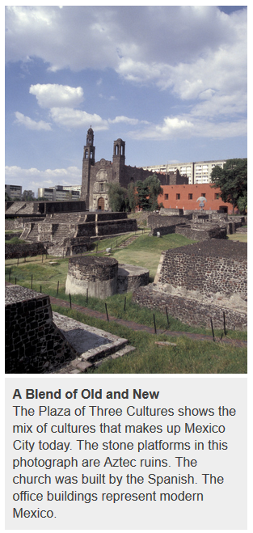
1. The Geographic Setting
Mexico City, one of the world’s largest cities in population, is located in a highland basin called the Valley of Mexico at about 7,000 feet above sea level. The valley is surrounded by mountains and has a mild climate and rich soil. The Valley of Mexico has been an important place of settlement since ancient times.
A City of Wonders: The Aztec Capital of Tenochtitlán The first settlers in the Valley of Mexico arrived thousands of years ago. At the time, several large, shallow lakes covered the valley floor. Small cities eventually grew up around these lakes.
In 1325, a group known as the Aztecs settled on an island in Lake Texcoco and founded a city called Tenochtitlán. The Aztecs were great warriors, and by conquering other groups, they created a mighty empire with Tenochtitlán as its capital. By the time the Spanish arrived in 1519, Tenochtitlán had become one of the greatest cities in the world, with an estimated population of around 200,000 people. Up to 1 million people lived in the Valley of Mexico.
Tenochtitlán was a city of wonders. One Spaniard said it was like an “enchanted vision” from a fairy tale. Great pyramids and temples towered above the city, and fine palaces and homes lined its streets and plazas. Many canals crossed the island, and three causeways, or raised roads, connected the island to the shore. A huge market sold exotic goods from throughout the Aztec Empire.
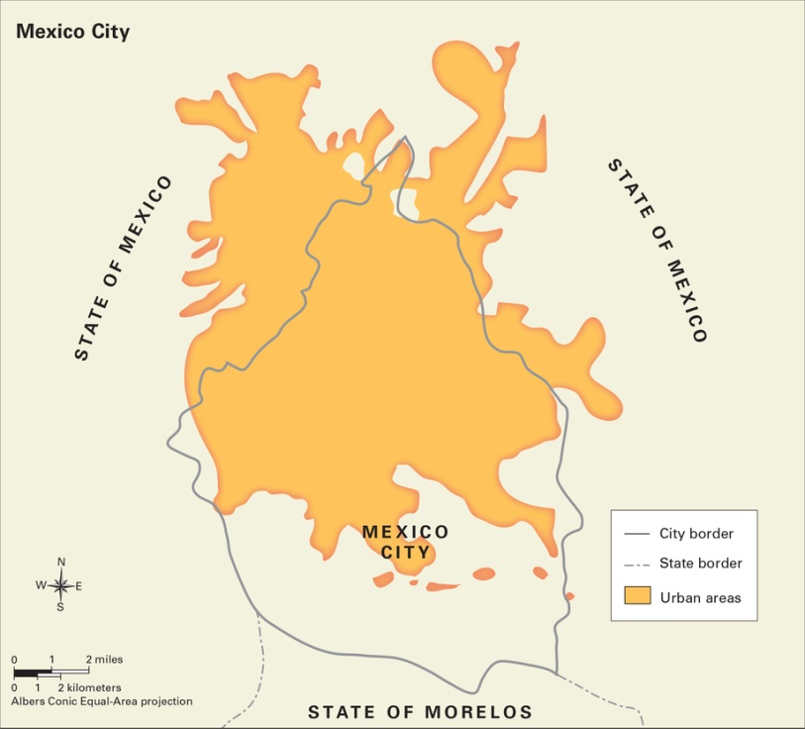
The people of Tenochtitlán enjoyed a high standard of living, a term that refers to people’s overall level of comfort and well-being. City residents had plenty of food from farming, fishing, and trade, and an aqueduct brought fresh water into the city from the surrounding hills. The houses in Tenochtitlán were well built, and people lived in clean, orderly neighborhoods.
A Bustling National Capital: Mexico City In 1521, Spain conquered the Aztec Empire, destroying Tenochtitlán and building a new city called Mexico City in its place. Over time, Mexico City became one of the most beautiful cities in the Americas.
Some 300 years later, in 1821, Mexico won its independence from Spain. Mexico City became the capital of the new country and continued to grow slowly. By the 1950s, the city was a blend of modern and historic buildings, and its broad avenues and tree-filled parks made it a pleasant place to live.
Today, Mexico City remains the center of Mexican life, but it is no longer the graceful city of old. In the past 50 years, urbanization, or city growth, has increased at a rapid rate. In 1970, the city had more than 8 million people. Ten years later, it had almost doubled in population. There are now more than 21 million people in Mexico City’s metropolitan area, which includes the city and its suburbs.
A key factor in Mexico City’s growth is migration from rural parts of the country to the city. Many people have relocated to the capital because of rural decline, or increasing poverty in the countryside. Life in rural areas is hard, but for many people, the city has become a difficult place to live, too, as you will see.

Geoterms
basin: a bowl-shaped depression, or hollow, in Earth’s surface
plaza: an open square or marketplace
standard of living: the overall level of comfort and well-being of a group or a country. People in developed countries generally have a higher standard of living than people in developing countries.
aqueduct: a pipe or channel built to transport water from one place to another]
urbanization: movement of people from rural to urban areas, resulting in the growth of urban areas
metropolitan area: a major population center made up of a large city and the smaller suburbs and towns that surround it
suburb: a developed area at the edge of a city that is mainly homes. Many suburbs also have stores and businesses.
rural decline: worsening economic conditions in the countryside, including rising unemployment and countryside, including rising unemployment and

Indicate whether the following statements are true or false.

_____ _____

_____ _____

_____

spatial inequality
Symbol: | Definition:
 | Sentence

standard of living:
Symbol: | Definition:
 | Sentence

urbanization
Symbol: | Definition:
 | Sentence

metropolitan area
Symbol: rural decline: | Definition:
 | Sentence

rural decline
Symbol: | Definition:
 | Sentence

2. Rural Decline Causes Urban Migration
Juan Ortiz and his family live in a small village in central Mexico, and like his father and grandfather before him, he is a farmer. He grows corn, beans, and other vegetables on a few acres of land that his family owns, but conditions have declined in the countryside. Juan can no longer support his family by farming, and now he is forced to seek other work. Like many farmers, Juan plans to leave his village and move to the city, making him a part of the large urban migration caused by rural decline in Mexico.
Farmers Struggle in the Countryside Life for most Mexican farmers is tough. Only about 15 percent of the land in Mexico is suitable for farming, while the rest is too dry, rocky, or mountainous to grow crops. In addition, a small number of wealthy landowners own most of the best farmland in Mexico.
There are several types of farms in Mexico. One type is the small, privately owned farm. Another type is the larger farm on communal land, or ejido, which is owned by a community of farmers who work the land. A third type of farm is a large commercial farm that grows food for export.
At one time, small farmers were the backbone of Mexican society, but now they are finding it difficult to survive. To compete with large farms, they have to increase their production. However, they lack the money to buy seeds, fertilizer, and farm machinery, so many ultimately end up selling their land. Sometimes they go to work for wages on the large farms, but such jobs are few and offer low wages. As a result, poverty and unemployment have increased in rural Mexico.
Migration to the City Brings Renewed Hope Faced with rural decline, many farmers choose to migrate to the city. There they hope to find jobs that will pay them a decent wage and provide their families with a higher standard of living. They also hope their children will have an opportunity to get a good education in city schools so that they can escape the cycle of poverty and find skilled jobs later.
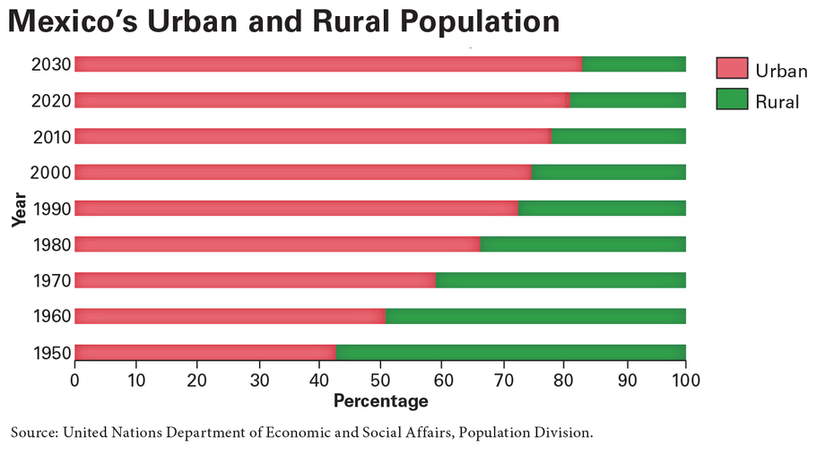
For years, most rural migrants headed to Mexico City, with migration rates peaking during the 1970s and 1980s. Since then, that rate has declined as life in Mexico City has become more difficult. Many migrants now choose to move to other cities in Mexico, while some try to cross the border into the United States.
The Urbanization of Mexico
This graph shows the percentage of urban and rural residents in Mexico over time. In 1950, more Mexicans lived in rural areas than in cities, but that had changed by 1960. Today, around 80 percent of all Mexicans live in cities. The graph also shows estimates for the future.
Geoterms
communal land: land that is held in common by a group of people
unemployment: joblessness
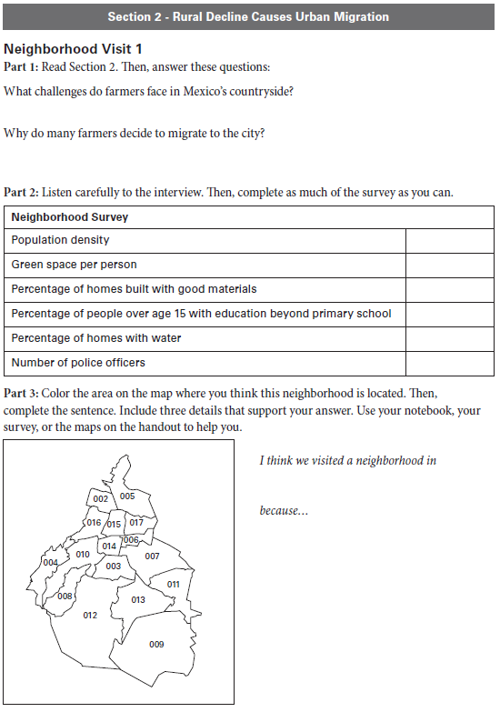

3. Urbanization Creates New Problems
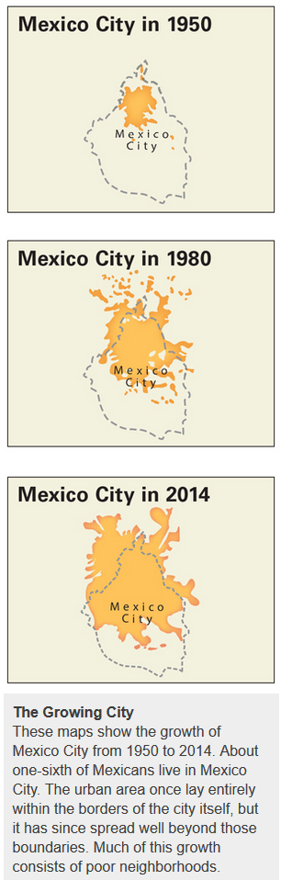
Julio César Cu is a professional diver, but he does not go diving in the ocean. Instead, he dives under the streets of Mexico City. On workdays, Julio puts on a special diving suit and swims into the city’s giant sewer system to remove trash and other objects from sewer pipes. Once he even found half a car. It’s a nasty job, but someone has to do it. Mexico City’s sewers are overloaded, and this is just one of the problems caused by rapid urbanization.
Too Many People, Too Little Land You have read that rural migration is a key factor in Mexico City’s growth. Large families have likewise played a part. Since the 1990s, however, both migration from rural areas and the number of children in the average family have declined. As a result, the city is growing slower than it once did.
In spite of this decreased growth rate, Mexico City is continuing to expand, with its suburbs spreading up the sides of the mountains that surround the Valley of Mexico. Newcomers are also filling in areas that were once covered by the valley’s lakes, which were drained long ago to enable expansion. However, there is still not enough land or housing for the city’s growing population.
Urbanization and overcrowding have caused problems in Mexico City. Clean water is in short supply, making sanitation difficult and aiding the spread of disease. Roads are clogged with traffic, polluting the air and making it difficult for people to travel from one place to another. Buses and subways are also packed. Mexico City is bursting at the seams.
Pollution, Poverty, and Crime Rapid growth has negatively affected Mexico City’s environment. One of the city’s worst problems is air pollution. Years ago, residents had a clear view of two great, snowcapped volcanoes that are located just east of the city, but now the mountains are rarely visible. A thick blanket of smog often hangs over the city, sometimes making it difficult just to see across the street.
Because of poor air quality, many city residents suffer from asthma and other illnesses. On some days, the air is so bad that schools are closed and people are warned to avoid going outside. Although recent laws to limit pollution have helped, the problem persists.
Social problems have also grown with urbanization. There are not enough jobs in the city to keep everyone employed, so poverty has increased. When poverty rises, crime does as well. Mexico City was once a relatively safe place to live, but now many residents fear for their safety.

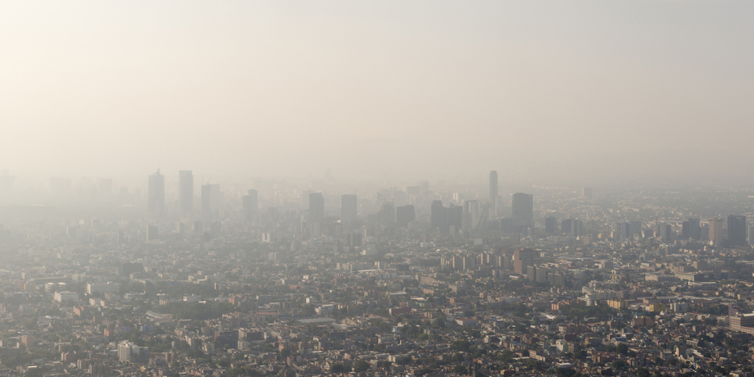
Polluted City Air
Mexico City has some of the worst air pollution in the Western Hemisphere. The city is surrounded by mountains that trap polluted air. The government has tried to reduce vehicle pollution and limit the number of vehicles on city streets, but there are still more than 5 million cars in the city.
Geoterms
pollution: damage to the natural environment caused by harmful substances; also refers to harmful substances
volcano: a break in Earth’s crust where magma and other material erupts from Earth’s interior
air quality: the condition of the air based on the amount of pollution in it

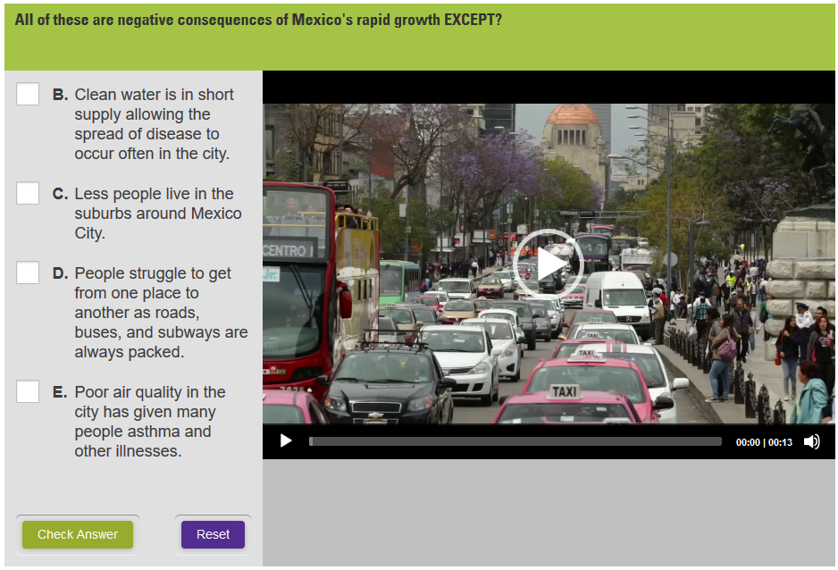

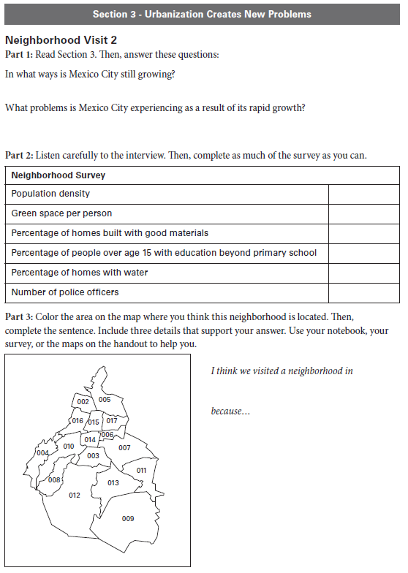

4. A City of “Haves” and “Have-Nots”
Sylvia Martinez lives in one of Mexico City’s huge garbage dumps. She sorts through piles of trash to find bits of glass, metal, and other materials that she can recycle for cash. She is one of the millions of “have-nots” in Mexico City.
The “have-nots,” poor people who have little money and few possessions, make up the majority of the city’s population. In contrast, the “haves” are people with money and comfortable lives. The differences between these two groups reflect the spatial inequalities of Mexico City.
The “Have-Nots” Struggle to Survive The poorest of the “havenots” are typically recent migrants to the city who often live in slums on the edge of town. Most houses in these slums are small shacks made of scrap metal and other refuse. Some of these houses lack electricity and running water. The streets of the slums are often unpaved and littered with trash, and many people who live in these slum areas have little or no work.
Migrants who have been in the city for a while may live in somewhat better conditions. Most have some kind of work, and many have multiple jobs, often working as maids, dishwashers, cooks, construction workers, street vendors, or bus drivers. Still, even migrants who have found a job end up working long hours for little pay. To make things worse, they may have to travel for hours by public transportation to get to their jobs.
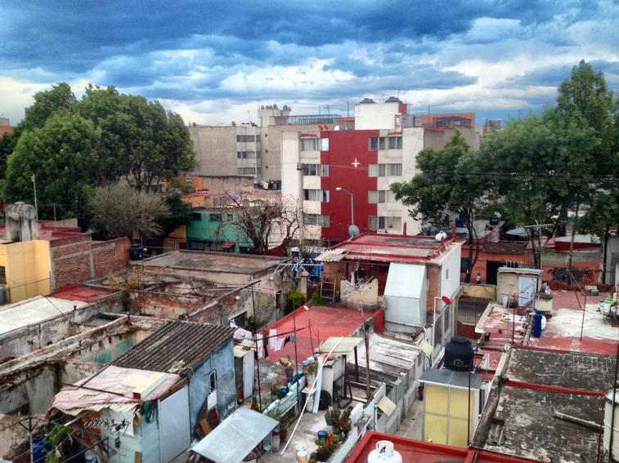
Recent arrivals are not the only people in Mexico City who are poor. Many city residents are “working poor,” which means that they have jobs that are too low-paying to lift them out of poverty. Most working poor live in working-class neighborhoods that are usually closer to the center of the city than the slums. Some live in cinder-block homes with metal or tar-covered roofs, while others live in large tenements, or run-down apartment buildings.

Housing for “Have-Nots”
Shacks like the ones seen here are located in slums on the outskirts of Mexico City. Houses are made of scrap wood and metal and sometimes use tarps for a roof. The people who live in these areas are often recent migrants to the city. Many end up selling cheap goods on the street or begging for a living.

Houses in working-class neighborhoods generally have electricity, but some lack running water. The streets are usually paved, though they are often in poor repair. While their lives are better than those of recent migrants, the working poor of Mexico City still face many struggles and uncertainties as they try to stay employed and provide for their families.
The “Haves” Live Well The “haves” are members of Mexico City’s middle and upper classes. They make up approximately one-fourth of the city’s residents.
A very small percentage of the “haves” belong to the upper class. These extremely wealthy people are large landowners or leaders in business or government. They enjoy a luxurious standard of living, many living on large castle-like estates with high walls and security systems. They often hire the working poor as their maids, gardeners, and drivers.
Members of the middle class live in houses or apartment buildings near the center of the city or in modern suburbs farther away. Many work in business, education, or government. They can usually afford some luxuries, such as smartphones. Moreover, many middle-class families have enough income that they can afford to pay for meals out, entertainment, and education.
In recent years, the Mexican middle class has expanded, and it is expected to continue to grow. Although around 47 percent of the nation’s households are middle class, falling back into poverty is a risk for many. In the first half of the 2010s, Mexico’s poverty rate actually increased. Moreover, wealth inequality remains, with around 10 percent of the population holding 65 percent of the wealth.
Geoterms
slum: an overcrowded, dirty area of a city where the housing is usually in very poor condition
tenement: a rundown apartment building
estate: a sizable area of privately owned property with a large house

Fill in the blanks with the correct work from the word bank
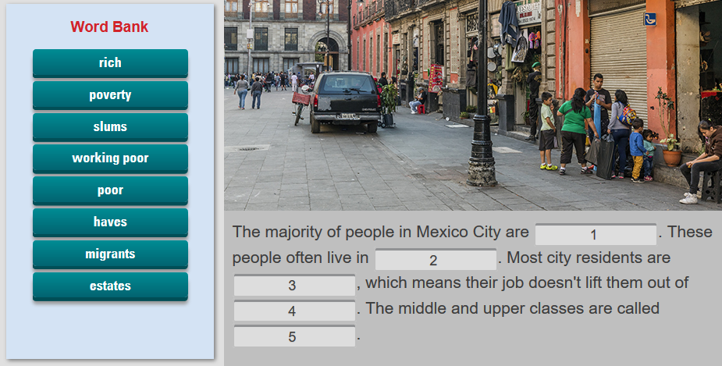

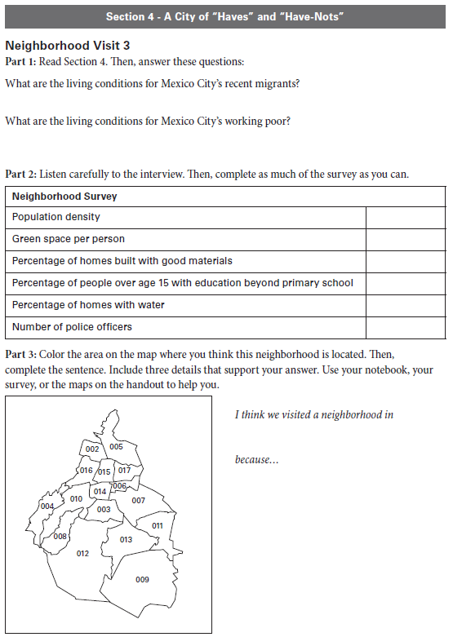

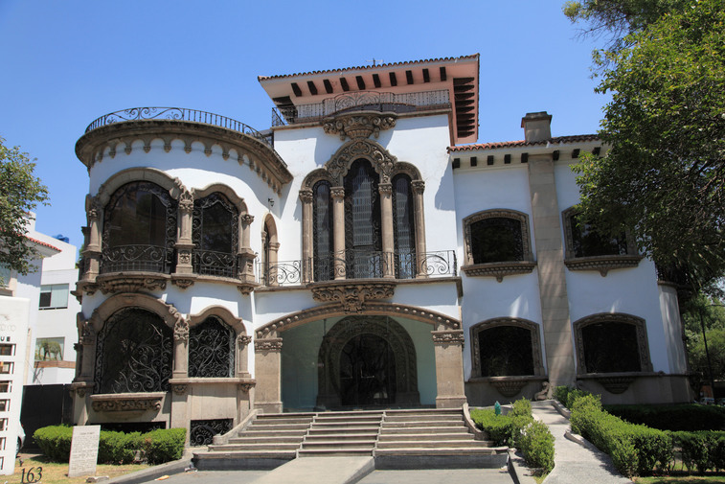
Summary
The Good Life
This home is located in a wealthy area of Mexico City. Homes like this often have large gardens and many rooms. They may also have security systems to guard against crime. Only a tiny portion of the city’s population can afford to live like this.
In this lesson, you learned about spatial inequality in Mexico City. You read how rural decline has increased migration to cities and learned about problems that have come with rapid urbanization. You have also seen how rich and poor have very different standards of living. These differences are clear in housing, transportation, and many other aspects of city life.
Spatial inequality does not exist only in large cities, but also in any area where differences in wealth affect how people live. You can observe such differences in standard of living in small towns as well as in suburbs and cities.
Spatial inequality also exists on a global scale. Think about global spatial inequality as you examine the map in the next section. The map compares the standard of living—measured by life expectancy, level of education, and per capita GDP—of people in countries around the world.
Match each term to the correct definition.
