Math Course 2 Syllabus
Mrs. Donna Zimmer
Beer Middle School
2018-2019

Contact Information
My Website: http://zimmerclass.weebly.com/
Tutoring Hours: Monday: 2:50 – 3:30 p.m.
Wednesday: 7:10 – 7:40 a.m.

Email: dzimmer@wcskids.net
Beer Middle School: 586-574-3175
My Extension: 25201 (Voicemail Only)
Conferences are available by appointment. The best way for parents to reach me is by email.

Course Description: The curriculum for this course aligns with the Michigan 7th Grade Standards for Mathematics, which may be viewed on the Michigan Department of Education website.
http://www.michigan.gov/documents/mde/K-12_MI_Math_Standards_REV_470033_7_550413_7.pdf

This year WCS middle schools are teaching a problem-based curriculum authored by Illustrative Mathematics. All course materials can be found online at https://im.openupresources.org/. On the right hand side of the screen under the For Students heading select your grade. Then select the unit and lesson you need.

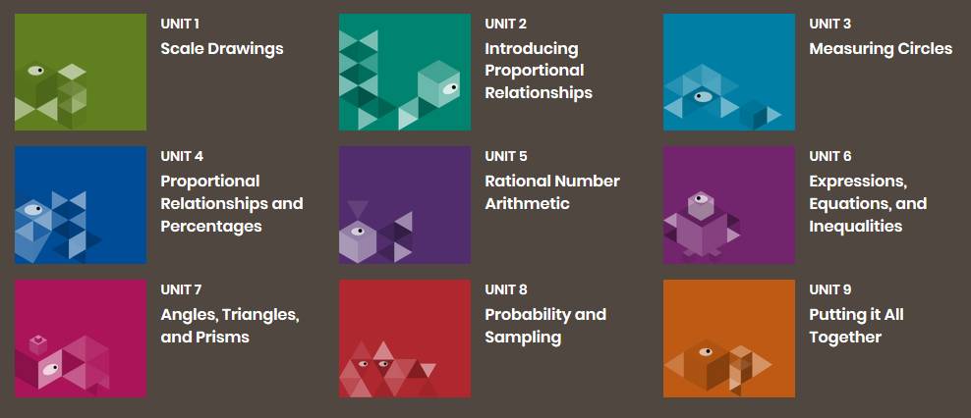

Required Materials: Students are required to bring the following materials to class EVERYDAY:
- Spiral Notebook
- ½ or 1 inch 3 ring binder (to be used only for Math Course 2)
- Pencils with erasers (Remember these need to be replenished throughout the year)
- Correcting Pen (Any color except blue or black)
- Black dry erase markers
- Planner/Agenda
- Glue sticks

Optional Materials:
- Box of Tissue to donate to the room
- Hand sanitizer to donate to the room
Grades: At Beer Middle School assessments (tests, quizzes, projects, etc.) determine 80% of final grades. Practice/Homework makes up the remaining 20% of final grades.

Grading Scale:
A+ 98+  A 97-93  A- 92-90 | B+ 89-87  B 86-83  B- 82-80 | C+ 79-77  C 76-73  C- 72-70 | D+ 69-67  D 66-63  D- 62-60 | E 59-50  F 49-0

Redo and Retake: Students are encouraged to redo/retake assessments on which they performed below their level of mastery (excluding the Final, District, and State Assessments). In order to be eligible to schedule a redo/retake time a student must complete the following tasks:
- Ensure all assignments for the unit of study are turned in.
- Meet with the teacher to establish criteria to be eligible for redo/retake
- Complete the redo/retake form and associated tasks.
- Submit a retake form signed by both the student and parent.
(A student’s opportunity to redo/retake an assessment is always subject to teacher discretion.)

Conduct Grade: This grade is an evaluation of a student’s behavior in class. Warren Consolidated Schools uses the following scale:

O Outstanding | S Satisfactory | N Needs Improvement

Classroom Conduct Guidelines: Students’ conduct grades are based on the following classroom rules:
- I arrived on time for class. (Prompt)
- I brought required materials (includes homework) to class. (Prepared)
- I was respectful to the teacher, peers & the learning process. (Polite)

Homework Policy:
- Practice work – In general students will have time to begin assignments in class. If students do not finish their work in class, it must be completed as homework. All practice work will be due the following class period.
- Late work – Practice assignments may be turned in late. They will be accepted up until the day before a given quiz or test. Late work will be marked down 10%.
- Absent work – Students have 2 days for each day absent to make up their work. It is the student’s responsibility to obtain missing notes or assignments.

Parent Portal: A student’s progress may be checked at any time through parent portal.

Login https://ps.wcs.misd.net/public/ | Questions - http://www.wcskids.net/ParentPortal/

Plagiarism/Academic Integrity: Academic integrity is expected on all assignments. Plagiarism is defined as presenting the work of another as one’s own. Cheating on an assignment or assessment is another activity that violates ethics and school rules. Any work that exhibits cheating/plagiarism, will result in a zero and parental notification. Additional disciplinary action may be taken.

Cell Phone Policy: Cell phones must be silenced and out of sight during class or they will be taken away and turned over to the office.
Math Course 2 Syllabus
Mrs. Donna Zimmer
Beer Middle School
2018-2019

I have read and understand the guidelines and policies for Ms. Zimmer’s Math Course 2.

Student Name: __________________________________

Student Signature: _______________________________ Date: _________________________

Parent Name: ___________________________________

Parent Signature: ________________________________ Date: _________________________

Communicating between parent and teacher by phone call is sometimes difficult. Teachers cannot answer the phone while students are in the room and parents are often at work when teachers try to call. Email is by far the easiest for teachers. If parents do not have access to email, it is possible to use the remind system to text.

Parent Email: ___________________________________________________________________
(Please print very carefully. Computers are picky)

Parent: Cell Phone: _______________________________________________________________

Any notes about your student or information that would make communication easier please write below.

____________________________________________________________________________________________________________________________________________________________________________________________________________________________________________________________________________________________________________________________________________________________________________________________________________________________________________________________________________________
Please return this page to Mrs. Zimmer by Monday, September 10th

